Feasibilty Study

Ray’s Rentals

Faran Azadi, Aamer Atique, Yusof Bandar, Naim Ahmed and Pritam Sangani

Table of Contents

1.0 Executive Summary 2

2.0 Problems 3

2.1 Lost or Missing Documents 3

2.2 Data Sharing 3

2.3 Retrieving Data 3

2.4 Security 3

2.5 Cost 3

3.0 System Requirements 4

3.1 Bike Record 4

3.2 Rental Record 4

3.3 Maintenance Record 4

3.4 Parts Record 4

3.5 Sold Bikes 4

3.6 Customer Record 4

4.0 Data Enquiries and Management Reports 5

4.1 Data Enquiries 5

4.2 Management Report 5

4.3 Types of Management Reports 5

4.3.1 Analysis Reports 5

4.3.2 Key Target Reports 5

4.3.3 Exception Reports 5

5.0 Data Enquiries 6

5.1 Data Enquiries 6

6.0 Management Reports 7

6.1 Analysis Reports 7

6.2 Key Target Reports 8

6.3 Exception Reports 9

7.0 Conclusion 10

8.0 Appendix 11

8.1 Bibliography 11

8.2 References 11

8.3 Log Book 11

8.4 Word Count 12

# 1.0 Executive Summary

This report will cover the advantages of using an electronic database in the context of Ray’s Rentals, a large bike rental shop in a small town. The owner feels as if he is losing business and is looking for an alternative, which can make his business easier. The current system is paper-based updating specific requirements such as bike record and rental records is inefficient and has caused problems for Ray, which has caused embarrassment several times with customers. The report will aim to put forward a more efficient model.

# 2.0 Problems

Ray’s Rentals currently uses a paper-based system for his bike shop. All data for the bikes such as type, unique number and maintenance history is all noted down on paper, any reservations for a bike are also noted down on paper including customer’s details such as name and number. This paper-based system has already caused problems for Ray’s Rentals bike shop.

## 2.1 Lost or Missing Documents

* The first problem with the current paper-based system is lost and missing documents. Ray has already stated that due to reservations being weeks in advance, “reservations can get lost among other reservations”. Being a paper-based system there are no backups if a reservation gets lost leading to reserved bikes being rented out to another customer.

## 2.2 Data Sharing

* The second problem is data sharing. Paper-based systems are located in one place, meaning that is Ray needed to access any records from home or share data with other employees this would be impossible. This lack of data sharing means a decrease in efficiency for Ray’s Rentals as data is only stored in one place.

## 2.3 Retrieving Data

* Slow access is another problem of a paper-based system. Finding and retrieving data in the paper-based system is very slow and inefficient and so it would be very difficult for Ray to retrieve any data about a certain customer or bike if required.

## 2.4 Security

* The fourth problem with a paper-based system is security. With a database, the data can be encrypted and safely stored, this cannot be done with a paper-based system, making the current system extremely unsafe.

## 2.5 Cost

* One of the biggest problems with a paper-based system is the high cost. All the problems stated above lead to a high-cost system. Firstly, the cost of materials for Ray will be extremely high as noting down every detail about each bike and customer takes a huge amount of paper and storage. Furthermore, the cost of organising documents to ensure document control and the labour cost is huge.

# 3.0 System Requirements

Below is a list of requirements that have been drawn up for the proposed new computerised database system for Ray’s Rentals.

To fully serve its purpose the new system should have 6 tables. The requirements for each table for the proposed new system are outlined below.

## 3.1 Bike Record

* This record should be used to keep track of all bikes that Ray’s Rentals have in stock. Each bike should have its own unique ID as per the current process.
* To improve usability, the record should include the option to filter by classification of, size, model, manufacturer and date of purchase of bikes that Ray’s Rentals have in stock.

## 3.2 Rental Record

* This record should be used to check for the availability of bikes for hire on any particular day and time.
* This record should also enable staff to enter customer details in order to reserve bikes and enter payment details

## 3.3 Maintenance Record

* This record should be able to flag up bikes that have not been serviced for a month
* Staff should also be able to update the record when bikes have been serviced
* There should also be a facility to record faults that have been reported by customers

## 3.4 Parts Record

* Staff should be able to use this record to check for stock levels of bike parts and be able to order parts that are low in stock. It could also flag up parts which are low in stock to reduce risk of missing parts that are low in stock
* This record should also allow staff to record deliveries of bike parts

## 3.5 Sold Bikes

* This record should allow the viewing of bikes that have been sold by Ray’s Rentals. Bikes that have been sold for two years should be deleted automatically from this record

## 3.6 Customer Record

* This record should be used to bring up details of customers’ who have reserved bike(s), such as name, address, the bike they have reserved and whether they have paid.

# 4.0 Data Enquiries and Management Reports

## 4.1 Data Enquiries

According to David Whiteley, a data enquiry is “the final type of report... All systems need to give the facility to look up each element of standing data and any transaction.” (Whiteley, 2013) In a database system, enquiries can be made about any details such as customer name, date or invoice. Usually, data enquiries are searched using a primary key, but can also be enquired by other details if the primary key is unknown. This is an operational level report; the output of the enquirer is usually displayed simply on the user’s screen. Data enquiries are a simple but efficient way of retrieving data.

## 4.2 Management Report

Management reports are used in organisations to outline how much money they have made or lost. These reports are utilised usually by high management or CEO/CFO’s so that they know how well the business is doing. These reports can be quarterly or annually depending on the size of the business and required purpose. The report can be used to strategize or see how well a new strategy is working.

## 4.3 Types of Management Reports

### 4.3.1 Analysis Reports

“The basic type of report is an analysis report that tabulates information on a two-dimensional grid” (Whiteley, 2013). Usually, an analysis report shows sales by region monthly, which can give a clear indication of how well Ray’s business is performing.

### 4.3.2 Key Target Reports

Key target reports are used to assess the performance of a business and “…would usually be aimed at the strategic and tactical management levels” (Whiteley, 2013). They usually compare the actual sales versus the targeted amount of sales.

### 4.3.3 Exception Reports

Exception reports are a summary considered out of the normal range. They are usually generated when an unusual situation occurs and requires specific attention. An example “…would be that of invoices not paid after a given period” (Whiteley, 2013)

# 5.0 Data Enquiries

## 5.1 Data Enquiries

Ray and his staff members will be making many data enquiries during the business’ operational hours. The enquiries made are usually relevant to the tasks required of the staff members. One scenario is when a customer requests to hire a specific bike. A data enquiry will need to be made by one of Ray’s staff to check if that particular bike is available to rent. A search/query could be made by searching the database using the model of the bike or the bike ID. Figure 1 illustrates this below.

Another example of a data enquiry at Ray’s Rentals is if a member of staff needs to know when a customer will be returning a bike. This could be because another customer is waiting for the same bike or the bike is due for maintenance, for example. An enquiry can be made using the booking reference and then checking the return date for that particular booking.

A third example is when Ray’s maintenance staff need to repair a bike. If they need to check if a part is available in the shop, they can simply do a search for the part using the part ID. If the part is available, the repairs can be done there and then. If not, the part can simply be ordered and the repairs can be scheduled.

Database

Search Result

Bike ID

*Figure 1*

# 6.0 Management Reports

## 6.1 Analysis Reports

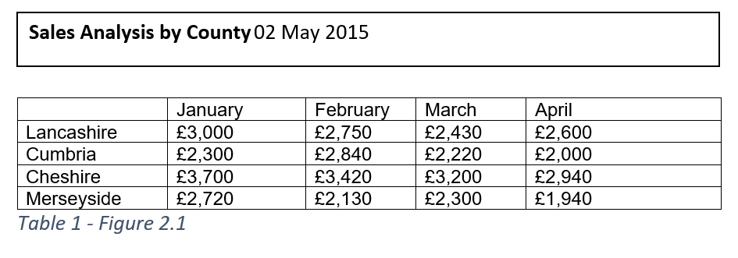

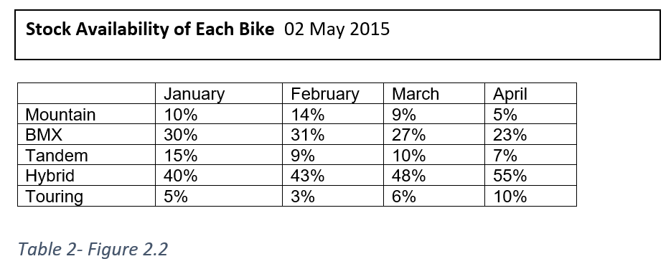

Tables figure 2.1 and figure 2.2 show data enquiries about Ray’s bike shop. Figure 2.1 is a data enquiry about the sale figures for the first quarter for 2015 of 4 counties in the North West. Figure 2.2 is a data enquiry about the stock availability of 5 different bikes which Ray’s bike shop offers for the first 4 months of 2015. Ray will be able to make data enquiries for future months and years.

Another example of a data enquiry Ray could make is to check which of the bikes Ray has the highest demand for, so, for example, Ray may want to buy more mountain bikes rather than buying BMXs as they are not really sought after in each of the counties.

## 6.2 Key Target Reports

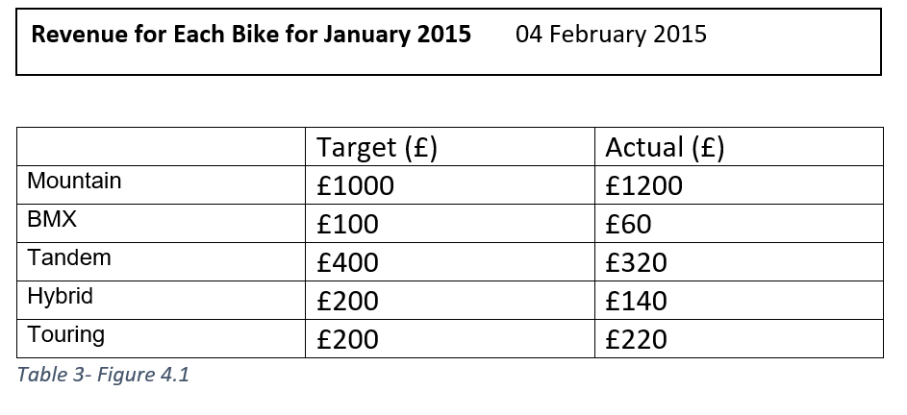

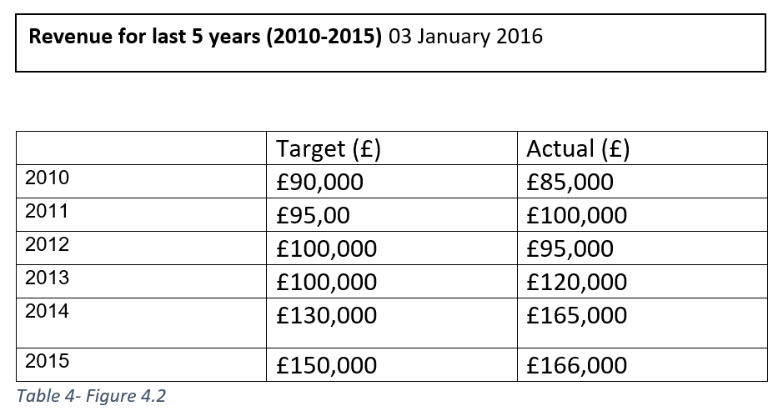

Tables figures 4.1 and 4.2 show data enquiries about the revenue for Ray’s bike shop. Figure 4.1 is a data enquiry about the revenue for the month of January 2015. The figures show the targeted revenue for each bike and the actual sale figures for each of the bikes. Figure 4.2 shows the data enquiries for the revenue made from the past 5 years (2010-2015) comparing the target revenue with the actual revenue.

Another example of a data enquiry Ray could make is to determine whether the business is viable and that it is making him money rather than losing him money each year. This could be used to check whether people are interested in renting out bikes.

## 6.3 Exception Reports

Exception reports, unlike analysis reports, will show Ray things that need ‘sorting out’ in the business. However, the chances are that Ray will need more information known as diagnosis information before he can understand or attempt to rectify the problem(s). If this does happen to be the case, an interactive report is produced. Generally, diagnosis information is accessed via the click of a button to avoid clutter on the page. An example of an exception report at Ray’s Rentals could be a list of all the customers that haven’t paid for the rental of a bike yet with the diagnosis information being the customer’s contact details such as phone number, address, e-mail etc. which will enable Ray or his management to deal with the problem directly. An example of this is below.

|  |  |  |  |  |  |
| --- | --- | --- | --- | --- | --- |
| Customer ID | Name | E-mail | Address | Total Owed | Paid |
| 1234 | Joe Bloggs | [j.bloggs@mmu.ac.uk](mailto:j.bloggs@mmu.ac.uk) | 123 Oxford St, Manchester | £100 | Yes |
| 12345 | Tom Smith | [t.smith@mmu.ac.uk](mailto:t.smith@mmu.ac.uk) | 124 Oxford St, Manchester | £200 | No |

# 7.0 Conclusion

In conclusion, this report outlines the benefits and increased flexibility a paperless system could offer Ray’s Rentals. It also highlights how important information can be represented in a variety of reports, which will assist Ray in minimising losses and increasing efficiency within the business.

# 8.0 Appendix

## 8.1 Bibliography

Chewning, C. (2013, July 21). *Exception Reporting- Improving Key Business Drivers*. Retrieved from Accounting Library: www.accountinglibrary.com/blog/exception-reporting-2/

Whiteley, D. (2013). *An Introduction to Information Systems.* Palgrave Macmillan.

## 8.2 References

Chewning, C. (2013, July 21). *Exception Reporting- Improving Key Business Drivers*. Retrieved from Accounting Library: www.accountinglibrary.com/blog/exception-reporting-2/

Whiteley, D. (2013). *An Introduction to Information Systems.* Palgrave Macmillan.

## 8.3 Log Book

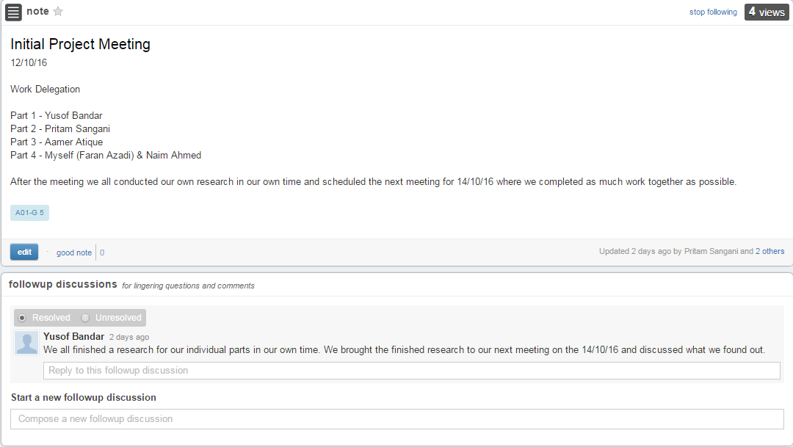

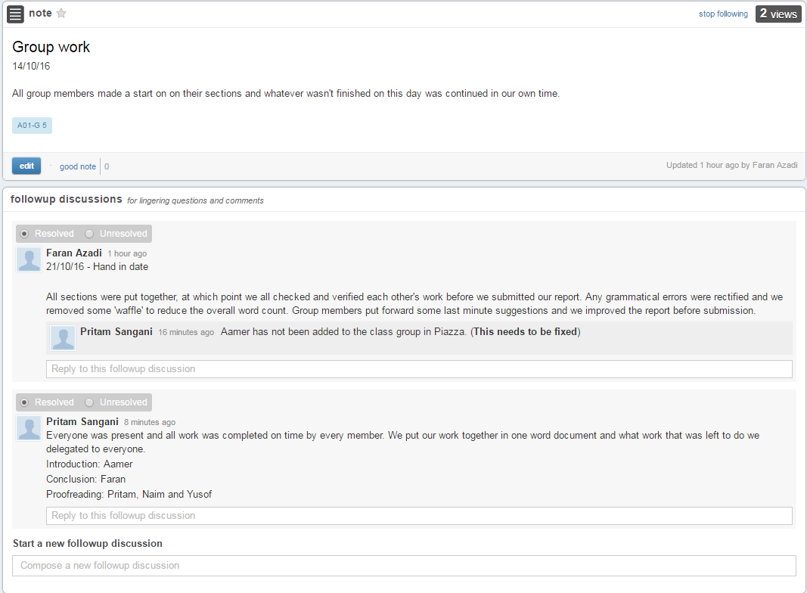

## 8.4 Word Count

With headings, contents, citations and appendix: 1966 words

Without headings, contents, citations and appendix: 1651 words